NEURAL NETWORKS & FUZZY LOGIC

ASSIGNMENT 1

2018-19

Perceptron and Fisher’s LDA

Team Members:

Prateek Dasgupta – 2016A1PS0602H

1. Implement the linear regression algorithm to estimate the weight parameters for the

feature matrix (X) and the class label vector (y). (a) Plot the cost function vs the number

of iterations. (b) Plot the cost function (J) vs w1 and w2 in a contour or 3D surf graph (w=

[w0 w1 w2]). Please use the dataset “data.xlsx”. (Use for or while loop for the

implementation)

Results and Observations:

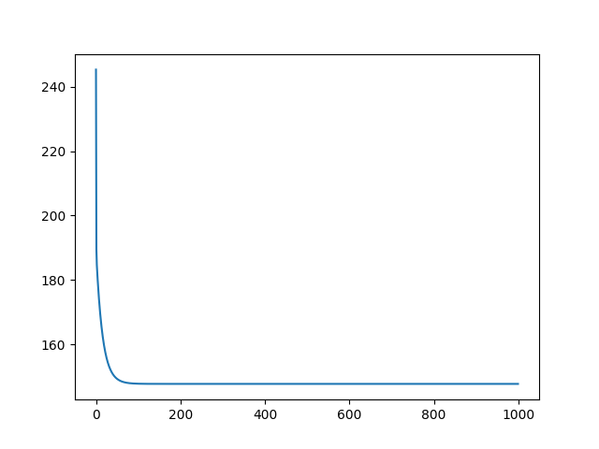

[5.80892024e-16 7.82445588e-02 6.13188430e-02]

147.71720552912467

A2

[-0.00038179 0.05752465 0.14055865]

Cost-function: 184.76058364742175

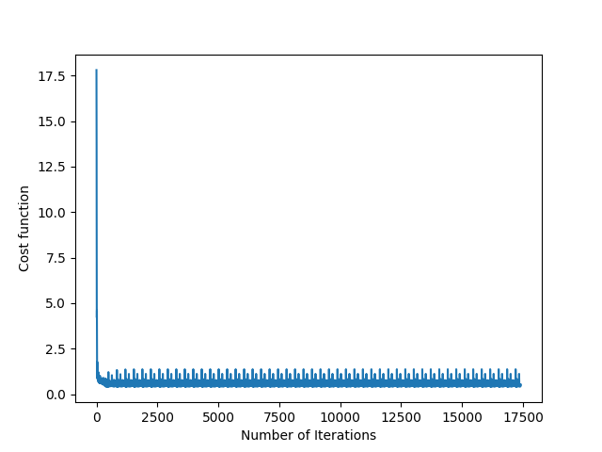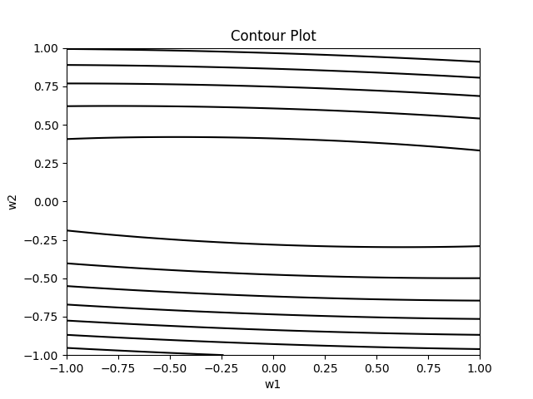

A3

Ridge Regression

1. Batch Gradient Descent

[0.26806643 0.97385346 0.37328987]

147.7174525620442

2. Stochastic Gradient Descent

[-0.01738926 0.069481 0.08272017]

150.44404411174588

A4

Cost function value: 174.81520434862384

A5 Lasso

1. Batch Gradient Descent

147.72069374086792

2. Stochastic Gradient Descent

150.95476205591356

[0.00614342 0.08101618 0.08433002]

A6 kmeans

Please enter number of clusters: 2

Initial clusters

309

39

iteration: 0

309

39

iteration: 1

181

167

iteration: 2

178

170

iteration: 3

175

173

iteration: 4

171

177

iteration: 5

170

178

iteration: 6

168

180

iteration: 7

168

180

iteration: 8

168

180

iteration: 9

168

180

A7

Logistic

Accuracy: 1.0

[[20 0]

[ 0 20]]

Specificity: 1.0

Sensitivity: 1.0

A8 Multiclass

1. One vs All Algorithm

Individual accuracy of class 0 = 1.0

Individual accuracy of class 1 = 0.7666666666666667

Individual accuracy of class 2 = 0.95

[[15 0 0]

[ 0 21 2]

[ 0 0 22]]

Overall accuracy = 0.9666666666666667

2. One vs One Algorithm

Binary Class: 12

Accuracy for Class 12 : 0.8

Binary Class: 13

Accuracy for Class 13 : 0.9833333333333333

Binary Class: 23

Accuracy for Class 23 : 0.9833333333333333

Overall Accuracy: 0.85

[[23 1 0]

[ 7 10 0]

[ 0 1 18]]

A9 5 fold cross validation

1. One vs All Algorithm

Batch 1

[[ 9 0 0]

[ 0 9 0]

[ 0 1 11]]

Individial accuracy = 0.9666666666666667

Batch 2

[[ 8 0 0]

[ 0 8 2]

[ 0 2 10]]

Individial accuracy = 0.8666666666666667

Batch 3

[[11 0 0]

[ 0 10 1]

[ 0 0 8]]

Individial accuracy = 0.9666666666666667

Batch 4

[[10 0 0]

[ 0 10 0]

[ 0 0 10]]

Individial accuracy = 1.0

Batch 5

[[11 0 0]

[ 0 7 3]

[ 0 0 8]]

Individial accuracy = 0.896551724137931

Overall Accuracy = 0.9395973154362416

2. One vs One Algorithm

Batch 1

Individual Accuracy: 0.9333333333333333

Batch 2

Individual Accuracy: 0.8

Batch 3

Individual Accuracy: 0.8333333333333334

Batch 4

Individual Accuracy: 0.8333333333333334

Batch 5

Individual Accuracy: 0.896551724137931

Overall Accuracy = 0.8590604026845637

A10

Likelihood Ratio Test

Class lengths: 28 , 32

Accuracy: 1.0

Confusion matrix

[[22 0]

[ 0 18]]

A11 MAP

Accuracy: 0.95

Confusion matrix

[[17 0 0]

[ 0 18 2]

[ 0 1 22]]

A12

Accuracy: 0.9777777777777777

Confusion matrix

[[16 0 0]

[ 0 16 0]

[ 0 1 12]]